**Practical-4**

**1.** **Implement a stack using an array having following functionalities:**

**a. isEmpty – to check if the stack if empty or not**

**b. isFull – to check if the stack if full or not**

**c. push – to insert the element into the stack**

**d. pop – to delete an element from the stack**

**e. print_top – to print the top most element of the stack.**

Aim:

To implement the concept of stack.

Theory:

In this practical we implemented the concept of pointers to structure and using it we implemented stack.

Code:

#include<stdio.h>

#include<stdlib.h>

struct Stack

{

  int top,size;

  int *array;

};

struct Stack* createStack(int size)

{

  struct Stack *s=(struct Stack *) malloc(sizeof(struct Stack));

  s->size=size;

  s->top=-1;

  s->array=(int *)malloc(sizeof(int)*size);

  return s;

}

int isEmpty(struct Stack *s)

{

  if(s->top==-1)

  {

    printf("The stack is Empty\n");

    return 1;

  }

  else

  {

    printf("The stack is not empty\n");

    return 0;

  }

}

int isFull(struct Stack *s)

{

  if(s->top==s->size-1)

  {

    printf("The stack is full\n");

    return 1;

  }

  else

  {

    printf("The stack is not full\n");

    return 0;

  }

}

int push(struct Stack *s)

{

  int item1;

  int g=isFull(s);

  if(g==0)

  {

    printf("Enter the value that is to be pushed=");

    scanf("%d",&item1);

    s->top=s->top+1;

    s->array[s->top]=item1;

    printf("Pushed the element to stack\n");

    return 0;

  }

  return 0;

}

int pop(struct Stack *s)

{

  int p=isEmpty(s);

  if(p==0)

  {

    s->top=s->top-1;

    printf("The element was poped\n");

    return 0;

  }

  return 0;

}

void print_top(struct Stack *s)

{

  printf("The topmost element is %d\n",s->array[s->top]);

}

int main()

{

  int size;

  printf("Enter the size value = ");

  scanf("%d",&size);

  struct Stack *s=createStack(size);

  printf("Enter a value for the following operation:\n");

  int x;

  while(1)

  {

    printf("1.For push operation \n2.For pop operation \n3.For the value of top \n4.To check if empty \n5.To check if full \n6.To exit\n");

    scanf("%d",&x);

    switch(x)

    {

      case 1:

        push(s);

        break;

      case 2:

        pop(s);

        break;

      case 3:

        print_top(s);

        break;

      case 4:

        isEmpty(s);

        break;

      case 5:

        isFull(s);

        break;

      case 6:

        exit(0);

    }

  }

}

Output:

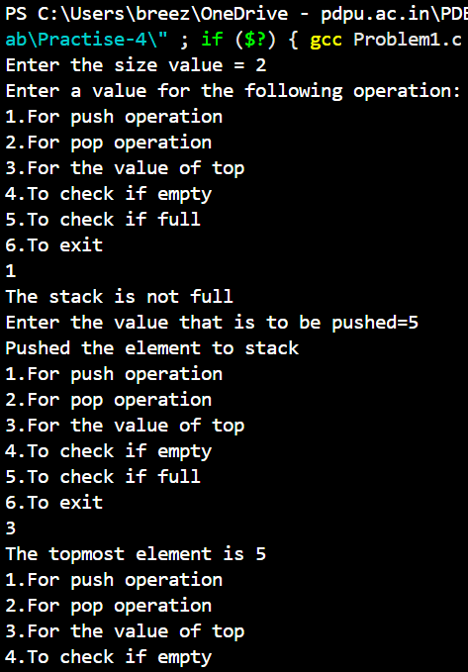

Link to all the code:

<https://github.com/PanavPatel06/DSA-Lab/tree/main/Practise-4>